Step 1 - Adaptation Scoping Exercise
This can be undertaken by the Adaptation Lead or as an exercise with the core adaptation working group. The aim is to define ongoing work that this plan has to align with, and to recognise any key opportunities (e.g. reviews of key policy) or barriers (e.g. construction work underway which may not have considered climate change).
Note: Do not worry about this being perfect or comprehensive at this stage. The goal is to begin thinking about where this plan will eventually sit and how it could support and be supported by current structures.
What is the aim of the Adaptation Plan?
Developing a living, integrated adaptation plan to enable a strategic and systematic approach towards resilience in a changing climate. The ambition is to engrain long-term change by enabling staff and decision-makers to see their value and role towards achieving climate resilience for current and future generations.
What is addressed in the plan?
The LGCAN cycle leads to an internal plan to prepare services and assets for the impacts of climate change through a qualitative risk assessment based on local knowledge, experience and expertise. This will result in development of an action plan which compliments and aligns with current structures.

Exercise 1
Take a moment to consider the following:
- Staff Time - How much time does the Adaptation Lead have to dedicate?
- Core Working Group - Are there a small number of colleagues who can form a core group to which some work can be delegated? What are their roles, and how much time do they have to allocate?
- Wider Working Group – Used for the larger workshops and consisting of most services if possible. After completing this scoping paper, you can use the other step 1 resources to fully develop an invite list.
- Financial Resource - Is this a corporate priority in your organisation? Do you need to begin having that discussion now?
- Senior Buy-in - What is the senior team buy-in like in general and how can it be developed?
- Data Gathering and Expertise - Are there any statistical or external research partnerships which you could draw on as the process develops?

Exercise 2
Paying close attention to the fact that this is an internal plan, examine ‘how adaptation fits within your organisation, its objectives and wider climate action.’

  - What are the Major initiatives relevant to adaptation in your organisation (e.g. Corporate Plan, LDP, Community Plan etc…)
  - What other policies are relevant? (eg. Procurement, emergency plans, health and safety)
  - Which of these major initiatives and additional policies are under development and could be an opportunity to integrate adaptation (E.g. timing of reviews, rewriting of priorities i.e. Covid-19 recovery)? Who is the contact?
  - Are there potential barriers within any of these policies? (e.g. Decisions ‘locked in’)
  - Finally, what external priorities are relevant for your organisations? For example, large private developments or central government projects which may have a significant impact on the region.

Example Output from Exercise 2:
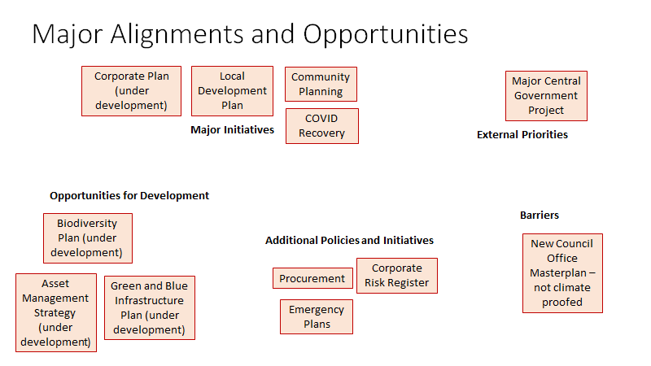

- Major Initiatives
- Corporate Plan
  - Opportunities: Currently under review by XX, resilience and climate change could be considered. Invite XX to working group.
  - Barriers: Current plan calls for waterfront development which may not have considered climate projections in masterplan. Contact XX to find out more detail.
- Local Development Plan
  - Opportunities - …
  - Barriers - ….

- Opportunities for Development (Plans currently being reviewed or created which should feature climate adaptation) Consider inviting relevant colleague to working group.
- Additional policies Not the headline initiatives, or currently under review but are important and need to be aligned with adaptation plan.
- Barriers Any significant projects or resource issues already locked in which may be a problem for adaptation in your organisation or region.
- External Priorities (perhaps led by external partners, but with great impact on council area e.g. private infrastructure development)

